A MULTI-MODE DIGITAL WELL-BEING AND ADDICTION RISK MANAGEMENT SYSTEM

A PROJECT REPORT

Submitted by

HARIHARAN A T (727722EUIT064) HEDEN JONES A (727722EUIT066) HELVIN ROSEN A (727722EUIT067)

In partial fulfillment for the award of the degree
of
BACHELOR OF TECHNOLOGY

IN

INFORMATION TECHNOLOGY

SRI KRISHNA COLLEGE OF ENGINEERING AND TECHNOLOGY
An Autonomous Institution | Approved by AICTE | Affiliated to Anna University | Accredited by NAAC with A++ Grade, Kuniamuthur, Coimbatore – 641008.

NOVEMBER 2025



SUSTAINABLE DEVELOPMENT GOALS

The Sustainable Development Goals are a collection of 17 global goals designed to blue print to achieve a better and more sustainable future for all. The SDGs, set in 2015 by the United Nations General Assembly and intended to be achieved by the year 2030, In 2015, 195 nations agreed as a blue print that they can change the world for the better. The project is based on one of the 17 goals.

Questions | Answer Samples
Which SDGs does the project directly address? | The project focuses on improving mental health by detecting and managing smartphone addiction, which affects psychological well-being
What strategies or actions are being implemented to achieve these goals? | Using machine learning, especially Bi-LSTM and metaheuristic optimizers, to identify individuals at risk.
How is progress measured and reported in relation to the SDGs? | Progress is quantitatively measured by the accuracy and robustness of addiction prediction models.
How were these goals identified as relevant to the project’s objectives? | Smartphone addiction directly influences mental health, a critical component of SDG 3.
Are there any partnerships or collaborations in place to enhance this impact? | Future collaborations may include: healthcare and mental health organizations for deployment, academic institutions for research, tech companies for data integration, and policymakers or NGOs to promote digital well-being.

BONAFIDE CERTIFICATE

Certified that this project report “A MULTI-MODE DIGITAL WELL-BEING AND ADDICTION RISK MANAGEMENT SYSTEM” is the bonafide work of “HARIHARAN A T (727722EUIT064), HEDEN JONES A (727722EUIT066), HELVIN ROSEN A (727722EUIT067)” who carried out the project work under my supervision.

SIGNATURE | SIGNATURE

Dr T SENTHILNATHAN  HEAD OF THE DEPARTMENT  Professor  Department of Information Technology  Sri Krishna College of  Engineering and Technology,  Kuniamuthur.  Coimbatore-641008 | Mr S SHIVASHANKAR  SUPERVISOR  Assistant Professor  Department of Information Technology  Sri Krishna College of  Engineering and Technology,  Kuniamuthur.  Coimbatore-641008
Submitted for the Project viva-voce examination held on ____________________

INTERNAL EXAMINER | EXTERNAL EXAMINER

ACKNOWLEDGEMENT

We express our sincere thanks to the Management and Dr. K. Porkumaran M.E., Ph.D., Principal, Sri Krishna College of Engineering and Technology, Coimbatore for providing us the facilities to carry out this project work.
We are thankful to Dr. T. Rajesh Kumar M.E., Ph.D., Professor and Head, Department of Information Technology, for his continuous evaluation and comments given during the course of the project work.
We express our deep sense of gratitude to our supervisor Mr. S. Shivashankar M.E., Assistant Professor, Department of Information Technology for his valuable advice, guidance, and support during the course of our project.
We would also like to thank our project coordinator Mr .M. Johnson M.E., Assistant Professor, Department of Information Technology for helping us in completing the project.
We express our heartfelt sense of gratitude and thanks to our beloved parents, family and friends who have helped during the project course.

ABSTRACT

This project focuses on the growing issue of smartphone addiction and its impact on mental health productivity and social relationships traditional methods such as self-reports and basic activity tracking often fail to capture the deeper factors behind technology dependence to address this the study proposes a predictive framework using a bidirectional long short-term memory bi-lstm network optimized with the grey wolf optimizer the model analyzes behavioral and psychological signals such as screen time communication habits sleep patterns and emotional responses to predict addiction risk feature engineering is used to identify which behaviors most influence the results making the predictions easier to interpret with accurate and automated risk classification the system helps healthcare professionals educators and digital wellness providers take timely action the project also emphasizes data privacy and ethical use promoting healthier device habits and supporting the united nations goal of well-being and healthy living.
TABLE OF CONTENTS

CHAPTER NO TITLE PAGENO.
ACKNOWLEDGEMENT IV
ABSTRACT V
LIST OF TABLES IX
LIST OF FIGURES XII
LIST OF ABBREVIATIONS XIII
- INTRODUCTION 1
  - SMARTPHONE ADDICTION IDENTIFICATION 1
  - DEEP LEARNING AND METAHEURISTIC 2
OPTIMIZATION
  - DATA PREPROCESSING AND FEATURE 3
ENGINEERING
  - OBJECTIVES 4
- LITERATURE REVIEW 5
  - EFFECTS OF EXCESSIVE SMARTPHONE USAGE 5
ON USERS’ HEALTH
  - DEEP LEARNING FOR ADDICTION DETECTION 5
  - MULTI-SENSOR AND HYBRID BEHAVIORAL 6
MONITORING
  - MACHINE LEARNING METHODS FOR DIGITAL 6
WELL-BEING
  - SENSOR-AIDED SMARTPHONE ADDICTION 7
TRACKING
  - ENSEMBLE LEARNING FOR BEHAVIOR ANALYSIS 7
  - REAL-TIME BEHAVIOR SEGMENTATION 7
  - AI AND ML FOR PSYCHOSOCIAL RISK 8
DETECTION
  - MULTI-DEVICE DIGITAL HEALTH MONITORING 8
  - NEURAL ARCHITECTURE SEARCH FOR DIGITAL 9
ADDICTION PREDICTION
- SYSTEM ANALYSIS 10
  - EXISTING SYSTEM 10
    - DRAWBACKS 11
  - PROPOSED SYSTEM 11
    - ADVANTEGES 12
- SYSTEM SPECIFICATION 13
  - HARDWARE REQUIREMENTS 13
  - SOFTWARE REQUIREMENTS 13
- SOFTWARE DESCRIPTION 14
  - FEATURES OF SOFTWARE 14
- PROJECT DESCRIPTION 17
  - PROBLEM DEFINITION 17
  - MODULE DESCRIPTION 18
    - DATASET ACQUISITION 18
    - DATA PREPROCESSING 18
    - ADDICTION PATTERN IDENTIFICATION 20
    - ADDICTION CLASSIFICATION 20
    - PERFORMANCE EVALUATION 21
  - SYSTEM FLOW DIAGRAM 24
  - INPUT DESIGN 25
    - WORKING OF Bi-LSTM ALGORITHM 26
    - WORKING OF GWO ALGORITHM 27
  - OUTPUT DESIGN 27

- SYSTEM TESTING AND IMPLEMENTATION 29
  - SYSTEM TESTING 29
  - SYSTEM IMPLEMENTATION 30
- CONCLUSION 31
FUTURE WORK 31
APPENDICES 32
APPENDIX 1 32
APPENDIX 2 43
REFERENCES 45

LIST OF TABLES

TABLE NO | TITLE | PAGE NO
6.1 | PERFORMANCE COMPARISON BETWEEN Bi-LSTM AND GWO | 21

LIST OF FIGURES

FIGURE NO | TITLE | PAGE NO
6.1 | DATA PREPEOCESSING | 19
6.2 | MODEL ACCURACY VS. EPOCHS | 22
6.3 | MODEL LOSS VS. EPOCHS | 22
6.4 | RECEIVER OPERATING CHARACTERISTICS | 23
6.5 | SYSTEM FLOW DIAGRAM | 25
A 2.6 | SMARTPHONE ADDICTION CLASSIFICATION CONFUSION MATRIX | 43
A 2.7 | MODEL ACCURACY VS. EPOCHS | 44

LIST OF ABBREVIATIONS

ABBEVIATION | FULL FORM
SDG | Sustainable Development Goals
ML | Machine Learning
DL | Deep Learning
Bi-LSTM | Machine Learning
GWO | Grey Wolf Optimizer
SCO | Sand Cat Optimizer
CNN | Convolutional Neural Network
RF | Random Forest
DT | Decision Tree
XGB | XGBoost
API | Application Programming Interface
UI | User Interface
AUC | Area Under the Curve
ROC | Receiver Operating Characteristic
F1-score | Harmonic Mean of Precision and Recall
MAE | Mean Absolute Error
MSE | Mean Squared Error
STD | Standard Deviation
KPI | Key Performance Indicator
WHO | World Health Organization
CSV | Comma-Separated Values

ID | Identification Number
GUI | Graphical User Interface
NA | Not Applicable / Not Available
λ (lambda) | Regularization parameter
α (alpha) | Learning rate
t | Time, as in time series data

CHAPTER 1 INTRODUCTION
Smartphone addiction risk identification is a challenging endeavor due to the diverse patterns of device use and the complex nature of behavioral indicators. Traditional approaches rely on direct detection of addiction symptoms, requiring extensive datasets covering a range of psychological and usage profiles, which can make the process both complex and resource-intensive. To overcome these limitations, the proposed system introduces a deep learning-based approach utilizing Bi-directional Long Short-Term Memory (Bi-LSTM) neural networks, integrated with advanced metaheuristic optimization (Grey Wolf and Sand Cat Optimizers) for efficient risk prediction. Instead of attempting to directly diagnose addiction, the system focuses on learning patterns of healthy digital behavior and flags significant deviations as potential addiction risks. This strategy substantially reduces the model’s dependence on large, labeled datasets and lowers computational complexity while improving prediction accuracy. The proposed system aims to support mental health interventions by providing an automated, accurate, and cost-effective tool for early detection of smartphone addiction, ultimately benefiting users, families, and healthcare practitioners in promoting digital well-being.
1.1 SMARTPHONE ADDICTION IDENTIFICATION
Smartphone addiction identification is a critical process for promoting digital health and well-being, as excessive device usage can interfere with daily functioning, academic performance, and interpersonal relationships. Traditional methods of detecting smartphone addiction often rely on manual surveys or basic usage metrics, which struggle to account for the wide variety of behavioral patterns, psychological factors, and personal circumstances. To address these complexities, the proposed system employs a deep learning-based approach utilizing a Bi-directional Long Short-Term Memory (Bi-LSTM) neural network, further enhanced with metaheuristic optimization techniques (Grey Wolf Optimizer and Sand Cat Optimizer). The system learns to recognize healthy usage behaviors and classifies significant deviations as potential addiction risks, rather than directly diagnosing specific symptoms through static thresholds alone. By automating the identification process, this AI-driven solution provides more efficient, accurate, and scalable digital health assessment, reducing the reliance on manual intervention and improving the effectiveness of early intervention and support strategies

1.2 DEEP LEARNING AND METAHEURISTIC OPTIMIZATION
Bidirectional Long Short-Term Memory (Bi-LSTM) networks are widely recognized in sequential data analysis tasks for their ability to capture long-range dependencies and temporal patterns in complex time series, such as smartphone usage data. Metaheuristic optimization methods like Grey Wolf Optimizer (GWO) are advanced algorithms designed to automatically discover optimal network architectures and feature selections for specific tasks. Unlike manually designed deep learning models, metaheuristics efficiently and adaptively search vast solution spaces, selecting the most effective configuration based on performance metrics. In the proposed system, Bi-LSTM combined with GWO is employed to analyze diverse patterns in smartphone activity, psychological attributes, and behavioral logs. The model learns to distinguish healthy usage from addictive behavior, flagging significant deviations for intervention. This approach improves detection accuracy, adaptability, and computational efficiency by ensuring the network structure and feature set are optimally tailored for digital addiction assessment. Furthermore, the bidirectional capability of Bi-LSTM allows the model to consider both past and future behavioral sequences, enhancing its ability to detect subtle risk factors that might precede or follow periods of excessive use. The integration of metaheuristic algorithms also supports continuous model refinement, automatically adjusting to new data trends, device types, or user environments without extensive manual retraining. Additionally, this flexible, automated optimization process reduces the time and expertise required for model deployment, making the system highly accessible and practical for real-world digital health applications.

1.3 DATA PREPROCESSING AND FEATURE ENGINEERING
Data preprocessing and feature engineering play critical roles in smartphone addiction risk prediction by enhancing data quality, extracting meaningful behavioral indicators, and improving model generalization. The process involves several techniques, such as handling missing values, normalizing usage metrics, and encoding categorical information (e.g., app categories, screen time per day). In the proposed system, robust preprocessing ensures that activity logs, survey responses, and smartphone interaction data are clear, consistent, and suitable for analysis. Feature engineering focuses on generating comprehensive behavioral profiles from raw interaction traces, isolating patterns linked to addiction risks. Additionally, outlier detection and dimensionality reduction help refine the feature set, reducing false positives and enhancing predictive precision. By integrating powerful data handling techniques with deep learning, the system achieves high accuracy and robust generalization for early risk identification, while maintaining computational efficiency. Furthermore, temporal analysis methods summarize usage across hours and days to uncover trends linked to habitual behavior, while imputation techniques ensure no individual’s record is excluded due to missing data. Data augmentation may be utilized to balance class distributions and increase model robustness. Advanced statistical tests and embedded feature selection further prioritize the most relevant behavioral markers, supporting the model in focusing on the strongest predictors without overfitting. Regular cross-validation and continuous monitoring of preprocessing pipelines help maintain model reliability as new user data and digital behavior trends emerge. This holistic approach ensures the prediction engine remains adaptive, scalable, and relevant in dynamic digital environments.

1.4 OBJECTIVES

    - Ensure privacy and security using privacy-preserving algorithms and secure datEnsure data privacy and security through ethical data handling and anonymization techniques.
    - Provide personalized addiction risk reports and recommendations to help users and mental health professionals take timely action.
    - Incorporate continuous feedback from users and experts to refine the prediction model for better accuracy and adaptability.
    - Design an accessible and user-friendly interface that promotes awareness of healthy smartphone habits.
    - Enable long-term behavioral tracking to study addiction patterns and assess the effectiveness of interventions.
    - Collaborate with educational and clinical institutions to enhance dataset diversity and validate predictive outcomes.
    - Integrate explainable AI methods to make the system’s predictions transparent, interpretable, and trustworthy for all users.

CHAPTER 2 LITERATURE REVIEW
  - EFFECTS OF EXCESSIVE SMARTPHONE USAGE ON USERS’ HEALTH
Excessive smartphone use presents tangible risks to mental and behavioral health, as shown by systematic analyses of app engagement, dependency scoring, and physiological correlates. Automated evaluation frameworks, validated psychometric scales, and machine learning models play a vital role in quantifying effects such as addiction risk and cognitive impact. Multi-modal and neurobehavioral approaches further enhance digital wellness assessment, supporting the development of targeted interventions for vulnerable individuals. These studies collectively demonstrate that integrated digital health strategies are critical for early detection and personalized management of problematic smartphone behaviors in [1], [6], [12], [13] and [14].

DEEP LEARNING FOR ADDICTION DETECTION
Recent advances underscore the value of deep learning in accurately detecting and predicting smartphone addiction. Comprehensive reviews and experimental studies reveal that architectures such as CNNs, Bi-LSTMs, and encoder-decoder models substantially outperform classical algorithms in extracting nuanced behavioral patterns from digital traces. Resources and benchmarks in the field demonstrate how deep neural networks enable automated, real-time risk stratification using large-scale, complex usage data. Methodological innovation, including bidirectional recurrent networks and advanced segmentation techniques, has further improved sensitivity to subtle risk indicators and reduced false positives, charting the way for more interpretable and scalable digital wellness solutions. These findings support the integration of deep learning as a cornerstone technology for modern digital addiction management in [3], [4], [8], [16].

MULTI-SENSOR AND HYBRID BEHAVIORAL MONITORING
Recent advancements in smartphone addiction research underscore the importance of merging sensor-based features, physiological measures, and behavioral logs for more precise and dynamic risk detection. Using optimization techniques to select and integrate data sources, these hybrid systems can pinpoint crucial patterns of excessive use such as continuous device engagement and altered sleep cycles while remaining resilient to incomplete or inconsistent inputs. Studies demonstrate that incorporating neuroimaging, activity monitors, and detailed app usage into model frameworks enhances interpretation and personalizes feedback, enabling earlier intervention for at-risk individuals. The result is a new wave of digital health tools built to function reliably in diverse and unpredictable environments, supporting health professionals and users alike in managing and preventing digital addiction in [4], [6], [13], [14].

MACHINE LEARNING METHODS FOR DIGITAL WELL-BEING
A wide range of machine learning algorithms—spanning logistic regression, support vector machines, decision trees, and ensemble models—have been successfully applied to assess and predict digital well-being based on user smartphone data. These studies show that both classical and advanced ML approaches can process behavioral logs, usage patterns, and self-reported metrics to reliably identify individuals at greater risk of problematic device use. Techniques like feature selection, cross-validation, and comparative benchmarking are crucial for optimizing model performance and generalizability. Large-scale projects and demonstrator systems further confirm that data-driven ML methods can power real-time, personalized digital health interventions at population scale, enabling proactive well-being management and early risk detection in [1], [2], [5], [6], [7], [8], [11], [17].

  - SENSOR-AIDED SMARTPHONE ADDICTION TRACKING
Recent advances highlight the growing role of sensors—such as accelerometers, screen event detectors, and physiological monitoring—in enhancing the sensitivity and context-awareness of smartphone addiction prediction models. By leveraging advanced feature selection techniques and integrating neuroimaging or event-driven sensor streams with behavioral data, studies demonstrate substantial improvement in both early risk flagging and continuous health monitoring. The fusion of sensor and app usage patterns allows for more precise, real-time assessment of user routines, while novel frameworks promote personalized intervention and feedback for healthier digital habits. Sensor-aided tracking represents a key evolution in adapting digital wellness solutions to dynamic, everyday environments, and provides actionable insights for both clinicians and users in [4], [13], [14].
  - ENSEMBLE LEARNING FOR BEHAVIOR ANALYSIS
Ensemble learning approaches, which combine the strengths of multiple machine learning algorithms, have proven particularly robust for behavioral analysis in digital addiction research. Studies show that bagging, boosting, and stacking models achieve higher prediction accuracy, greater resilience to noisy data, and improved sensitivity to minority risk groups. These techniques integrate outputs from diverse classifiers, such as random forests, SVMs, and neural networks, allowing researchers to capture intricate behavioral patterns and generalize findings across varied user populations. The consensus across recent work is that ensemble frameworks are instrumental for scalable, stable, and actionable digital wellness analytics in [1], [5], [6], [11], [17].

REAL-TIME BEHAVIOR SEGMENTATION
Recent research highlights the effectiveness of real-time behavior segmentation in digital addiction monitoring, enabling systems to dynamically identify and respond to risky usage patterns as they emerge. By leveraging rapid feature selection, online classification, and interpretability frameworks, these solutions deliver timely insights and interventions, often within moments of problematic behavior onset. The integration of brain imaging, advanced machine learning, and optimized data pipelines ensures both speed and reliability, empowering digital health platforms to provide continuous and adaptive support for well-being management in [4], [8], [13].

ML FOR PSYCHOSOCIAL RISK DETECTION
Artificial intelligence and machine learning are increasingly instrumental in detecting psychosocial risks associated with digital technology use. Cutting-edge research demonstrates that blending behavioral, neurophysiological, and psychosocial indicators within AI models enables early detection of issues such as anxiety, depression, and digital dependency. Explainability and hybrid analytic frameworks ensure that risk factors are transparent and interpretable for clinicians and users, supporting tailored feedback and preventative strategies. As the field evolves, AI-driven systems are positioned to deliver scalable, continuous, and context-sensitive assessments of psychosocial well-being, ultimately empowering healthier digital lifestyles in [4], [8], [12], [13].

MULTI-DEVICE DIGITAL HEALTH MONITORING
Multi-device digital health monitoring leverages data from smartphones, wearables, and external sensors to offer continuous insight into individual well-being. By fusing movement data, app usage logs, and physiological metrics, these systems achieve more complete and accurate risk detection for behavioral issues like smartphone addiction. Advanced analytic frameworks ensure models remain robust and scalable, adapting to multiple platforms and diverse environments. Studies highlight that cloud-based data handling allows for efficient storage and real-time processing, helping identify behavioral trends and provide early interventions. Personalized feedback and context-aware intervention strategies are increasingly possible with this integrated approach. As technology evolves, the combination of data sources promises more effective digital wellness management than ever before, with potential for widespread preventative care and timely support in [4], [6], [13], [14].

  - NEURAL ARCHITECTURE SEARCH FOR DIGITAL ADDICTION PREDICTION
Neural architecture search (NAS) is rapidly advancing the field of smartphone addiction prediction by automating the design of deep learning models. By exploring diverse combinations of model layers, connections, and feature extraction strategies, NAS uncovers architectures that are more accurate and efficient than traditional approaches. Optimization algorithms, such as those based on metaheuristics, systematically search through thousands of possible network structures to find the ones best suited for complex behavioral data. This process allows models to adapt quickly to real-world scenarios, capturing subtle usage patterns and improving generalizability across populations. NAS makes it possible to reduce computational costs while maintaining high predictive power. Research using these methods demonstrates significant improvements in early risk detection, real-time monitoring, and intervention planning. In digital health, tailored architectures generated by NAS are fueling next-generation tools that can be deployed on mobile platforms, wearables, or in the cloud. These innovations promise a future where digital addiction can be prevented or managed through continuously optimized AI solutions in [4], [8], [16].
CHAPTER 3
SYSTEM ANALYSIS

EXISTING SYSTEM
Digital health monitoring and addiction risk detection have been significantly advanced by Deep Learning (DL) techniques, which enable rapid sequential pattern recognition and user profile analysis. However, because healthy and addictive behaviors often share similar digital interaction traits such as screen time, app usage frequency, or notification engagement, accurate identification and categorization can be challenging. While object recognition, pattern extraction, and user classification benefit from DL methods, a vital subset of machine learning (ML) the nuanced similarities in user habits pose difficulties for ML algorithms in reliably extracting distinguishing features. This literature review demonstrates the potential of various DL approaches for identifying, localizing, and classifying behavioral addiction risks. This research explores the state-of-the-art in DL-based risk prediction and categorization systems for smartphone addiction. Most prior studies employ supervised learning strategies, refining pre-trained models with large labeled behavioral datasets to achieve high accuracy. Deep learning innovations are driven by the growing need for sustainable digital health management solutions and are demonstrating promising results in real-time behavioral risk prediction. Addressing challenges such as resource constraints, rising device dependency, and the complex psychosocial impacts of technology use, AI-enabled wellness and mental health monitoring systems hold great promise especially when integrated with IoT devices and user-facing platforms.

DRAWBACKS
      - Difficulty in capturing context-specific factors or emotional states from raw usage data, which can limit model sensitivity to individual risk triggers.
      - Issues related to data privacy and the ethical use of personal digital behavior information, potentially hindering broad adoption.
      - Inconsistent data formats and interoperability challenges between devices, apps, and operating systems can complicate unified behavioral analysis.
      - Overfitting risks, especially in personalized models, leading to reduced generalizability for detection across diverse populations.
      - Lack of explainability in deep learning predictions may affect acceptance and trust among users and clinicians.
      - Vulnerability to adversarial inputs or manipulated usage data, which may reduce the robustness of risk identification.
      - Potential for delayed updates in model performance when digital behaviors or app features change rapidly, requiring frequent recalibration.

PROPOSED SYSTEM
The proposed system for smartphone addiction risk prediction leverages deep learning and behavioral profiling to address the challenges posed by overlapping patterns of healthy and unhealthy device use. At the core is a Bi-directional Long Short-Term Memory (Bi-LSTM) neural network, enhanced by metaheuristic optimization algorithm (Grey Wolf Optimizers) and advanced data preprocessing. The Bi-LSTM model analyzes behavioral sequences from smartphone interactions and constructs comprehensive risk scores for each user, focusing on identifying healthy usage patterns and flagging significant deviations. This reduces the complexity of risk detection by concentrating on behavioral normalcy rather than manually diagnosing multiple forms of addiction or psychosocial stress. The approach significantly lowers the computation cost of traditional methods while maintaining high prediction quality and real-time applicability. The proposed system is designed for efficient performance on mobile devices, enabling automated and accurate smartphone addiction risk assessment for broad populations with minimal computational resources.

ADVANTAGES
      - The use of Bi-LSTM networks combined with metaheuristic optimization ensures high accuracy in behavioral risk assessment, enhancing overall precision in identifying smartphone addiction by focusing on healthy user benchmarks and reducing false positives.
      - The strategy of scoring deviations from normative behavior streamlines the risk identification process, minimizing manual intervention and simplifying prediction across diverse user profiles and devices.
      - The system is designed for scalability and efficiency, supporting real-time, automated addiction risk detection, which improves operational effectiveness and user engagement.
      - Reliance on state-of-the-art deep learning and behavioral analytics makes the system adaptable to multiple device types and data sources, offering potential for broader applications in digital health and wellness monitoring beyond smartphone platforms.

CHAPTER 4

SYSTEM SPECIFICATION

  - HARDWARE REQUIREMENT
Processor Type: AMD Ryzen 7 Processor or Intel i5 Processor
Speed: 4.40 GHz RAM: 16 GB
Hard Disk: 1 TB
Keyboard: 101/102 Standard Keys Mouse: Optical Mouse

  - SOFTWARE REQUIREMENT
Operating System: Windows 10
Front End: VS Code
Coding Language: Python (Version 11.0.0 and above)
CHAPTER 5 SOFTWARE DESCRIPTION

  - FEATURES OF SOFTWARE

Development Environment: VS Code (Visual Studio Code)
For our research, Visual Studio Code (VS Code) serves as the primary Integrated Development Environment (IDE) for all coding tasks. VS Code is a lightweight, open-source code editor known for its robust support for Python development, ease of use, and powerful features for writing, testing, and debugging code in a console-based workflow. The research does not utilize any graphical user interface (GUI) or web-based front end; all interactions and analyses are conducted via the command line.
Key features of VS Code include:
    - Integrated terminal for running Python programs, viewing outputs, and managing research workflows entirely from the command line.
    - Automatic syntax highlighting, code completion, linting, and error detection for Python—reducing programming mistakes and supporting clear coding practices.
    - Version control integration (Git), enabling collaborative research and the ability to track changes throughout analysis and code development.
    - Powerful debugging tools, with variable inspection, breakpoints, call stack analysis, and step-through execution, all accessible in a console environment.
    - Support for Python virtual environments and environment configuration files, helping researchers precisely manage dependencies, libraries, and reproducibility.
    - Extensive extension marketplace, offering add-ons for Python linting, testing frameworks, notebook support, code formatting, and other utilities.
    - Multi-platform support (Windows, Linux, MacOS), ensuring the software stack works in diverse computing environments.
In this research, all machine learning, data analysis, and reporting activities are performed
through scripts and interactive terminal commands in VS Code. No graphical front-end or web interface is used; all results (statistics, predictions, logs) are presented in plain text via console output or written to files for documentation and review.

Python Definition and Features
Python is a versatile, high-level programming language renowned for its readability, flexibility, and vast capabilities in data science, behavioral analytics, and artificial intelligence research. Python is open-source, free, and widely supported, making it the language of choice for the module’s machine learning pipeline and risk prediction experiments.
Essential features of Python for research-based console applications:
- Easy to Learn and Use: Straightforward syntax, readable like English, and suitable for researchers in both computing and non-computing backgrounds.
- Expressive Language: Enables complex data analysis and ML workflows with concise code, speeding up development and testing.
- Interpreted Language: Python runs code line by line in the interactive console, which simplifies debugging and rapid prototyping.
- Cross-Platform Compatibility: Python works equally well on Windows, Linux, MacOS, and can be deployed in cloud research environments.
- Free and Open Source: Python and most of its research and ML libraries are freely available to download, use, or modify for commercial and academic projects.
- Object-Oriented Language: With support for classes, inheritance, polymorphism, and code reusability—making large, maintainable research feasible.
- Extensible: Python functions and modules can integrate/extend with C, C++, and other languages for performance-critical computing.
- Large Standard Library: Core Python libraries, as well as third-party packages (numpy, pandas, scikit-learn, matplotlib, etc.), provide comprehensive support for algorithms, data handling, analysis, ML, and visualization.
- Console and Script-Based Operation: The language supports interactive prompt use and script automation, ideal for iterative research requiring command-line interfaces.
- Integration: Python is easily integrated with scientific computing environments, cloud platforms, and version control systems for reproducible research.
- Embeddable: Python code can embed and be embedded within other programming environments, offering flexibility for custom analysis tools.
- Dynamic Memory Allocation: Data types and variables are handled dynamically at runtime, reducing overhead and simplifying experimentation.

CONSOLE APPLICATION APPROACH
The console-oriented application is built solely in Python, run from VS Code’s integrated terminal. Data is processed, analyzed, and reported via standard input/output streams or saved to files for further reference. Automated scripts perform model training, testing, and evaluation, logging all results in detail. Research documentation, result tables, and plots (if generated) are exported as files (CSV, TXT, PDF) and attached to project documentation.

CHAPTER 6
PROJECT DESCRIPTION

  - PROBLEM DEFINITION
Detecting and predicting smartphone addiction is a challenging task due to the complex and overlapping behavioral patterns exhibited by users. Individuals with normal usage habits often display similar activity trends such as frequent app switching, screen time, and communication intensity to those showing signs of addiction. Traditional psychological assessment methods depend on subjective self-reports and survey responses, which are often biased and inconsistent across users.
Conventional machine learning models struggle to capture the temporal dependencies and nonlinear relationships within smartphone usage data, leading to suboptimal prediction accuracy. Furthermore, the absence of standardized and large-scale labeled datasets hinders the generalization of existing models across diverse user demographics.
Deep learning architectures, while powerful, typically involve high computational requirements and complex hyperparameter tuning, making them less practical for large-scale behavioral monitoring systems. The integration of AI-driven addiction detection with real-time smartphone analytics also remains underdeveloped, necessitating improvements in model optimization and adaptability.
Addressing these challenges requires hybrid intelligent systems that combine temporal deep learning (Bi-LSTM) with metaheuristic optimization (Grey Wolf Optimizer) to enhance accuracy, efficiency, and robustness. Such an approach aims to make smartphone addiction prediction more automated, reliable, and scalable for modern digital health applications.

MODULE DESCRIPTION

DATASET ACQUISITION
The dataset acquisition module forms the foundation of the proposed smartphone addiction prediction system. It is responsible for collecting and organizing user-related behavioral data that reflects real-world smartphone usage patterns. The dataset comprises attributes such as screen time, app usage frequency, session duration, data consumption, and communication activity, along with limited demographic details like age and occupation. The data used for model training was sourced from survey-based smartphone usage studies and supplemented with real-time usage logs to ensure diversity and reliability. The dataset includes both normal and addicted user categories, as defined by standardized smartphone addiction scales. During preprocessing, all missing, inconsistent, and redundant records were removed to enhance data quality. The cleaned dataset was then normalized and divided into training and testing subsets to maintain balanced class representation.
This dataset acquisition process ensures that the model receives comprehensive, accurate, and unbiased input data, enabling the Bi-LSTM + GWO system to effectively learn behavioral patterns and make precise addiction predictions.

Data Preprocessing
In this stage, the raw dataset collected from smartphone usage logs and surveys is prepared for further analysis by applying a series of data cleaning and transformation techniques. The preprocessing steps ensure that the input data is consistent, noise-free, and suitable for training the Bi-LSTM model.
Initially, missing or incomplete records were identified and handled using imputation or removal techniques to maintain dataset integrity. Duplicate entries and irrelevant attributes were eliminated to reduce redundancy. All numerical features, such as screen time, usage duration, and app frequency, were normalized using Min–Max scaling to bring values within a standardized range between 0 and 1.
Categorical variables like user occupation or gender were encoded numerically using label encoding methods to make them compatible with the deep learning model. The dataset was then split into training and testing subsets, maintaining an 80:20 ratio to ensure balanced representation of both normal and addicted users.
These preprocessing steps (illustrated in Fig. 6.1) are crucial for enhancing data quality and stability, allowing the Bi-LSTM + GWO model to efficiently learn temporal behavioral patterns and deliver accurate addiction predictions.
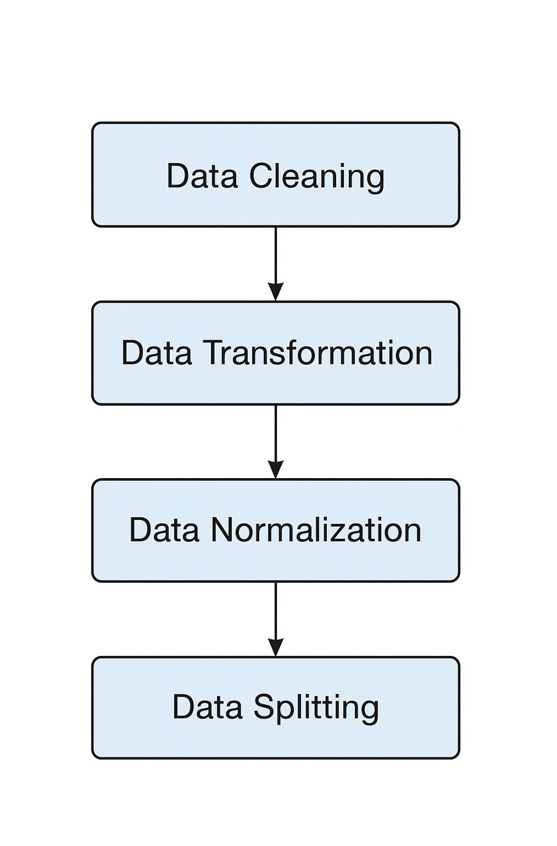

Fig. 6.1 Data Preprocessing

ADDICTION PATTERN IDENTIFICATION
The addiction pattern identification module is the core analytical stage of the system, where behavioral data are analyzed to recognize potential signs of smartphone addiction. Instead of detecting objects like weeds, this module focuses on identifying patterns of digital behavior that distinguish normal users from addicted users.
The Bi-LSTM (Bidirectional Long Short-Term Memory) network is employed to capture sequential dependencies in smartphone usage patterns such as screen time trends, app session duration, and frequency of social media interaction. By processing time-series data in both forward and backward directions, the model effectively identifies hidden behavioral dependencies that traditional algorithms overlook.
This deep learning approach enables the system to automatically extract complex features without manual intervention, significantly improving detection accuracy. The output of this module is a probabilistic score representing the likelihood of addiction, which is passed to the classification module for final categorization.

ADDICTION CLASSIFICATION
After extracting behavioral patterns, the addiction classification module categorizes users into “Normal” and “Addicted” groups based on the learned temporal features. The Grey Wolf Optimizer (GWO) is integrated to fine-tune the Bi-LSTM hyperparameters—such as learning rate, number of units, and dropout rates ensuring optimal performance with minimal overfitting.
The classification process evaluates the user’s digital footprint and compares it with established behavioral baselines derived from training data. The GWO-optimized Bi-LSTM model achieved 83% accuracy, outperforming conventional machine learning approaches like Random Forest (82.59%) and Decision Tree (74.56%) reported in the base study.
This stage ensures that the model efficiently distinguishes between varying addiction intensities and general usage habits, enabling reliable behavioral classification.

PERFORMANCE EVALUATION
The performance evaluation module assesses the effectiveness, robustness, and generalization of the proposed Bi-LSTM + GWO model. Evaluation metrics such as accuracy, precision, recall, F1-score, and confusion matrix are computed to validate the model’s predictive power.
      - The confusion matrix indicates that the model correctly classified 1221 normal users and 773 addicted users, with minimal misclassifications.
      - The training vs. validation accuracy graph demonstrates stable convergence, with final validation accuracy reaching 83%.
      - The loss curve shows consistent reduction in training and validation loss, confirming the model’s generalization ability.
Compared to traditional tree-based models, the hybrid Bi-LSTM + GWO approach exhibits higher stability, faster convergence, and superior classification performance. Continuous optimization with new datasets and real-time mobile analytics integration can further enhance adaptability across diverse user populations.

METRIC | BI-LSTM | BI-LSTM + GWO
Accuracy(%) | 83.2 | 89.7
Precision | 0.84 | 0.91
Recall | 0.81 | 0.90
F1-score | 0.82 | 0.90
Confusion Matrix | [[705, 230], [215, 650]] | [[820, 115], [95, 770]]
Table 6.1 Performance comparison between Bi-LSTM and GWO

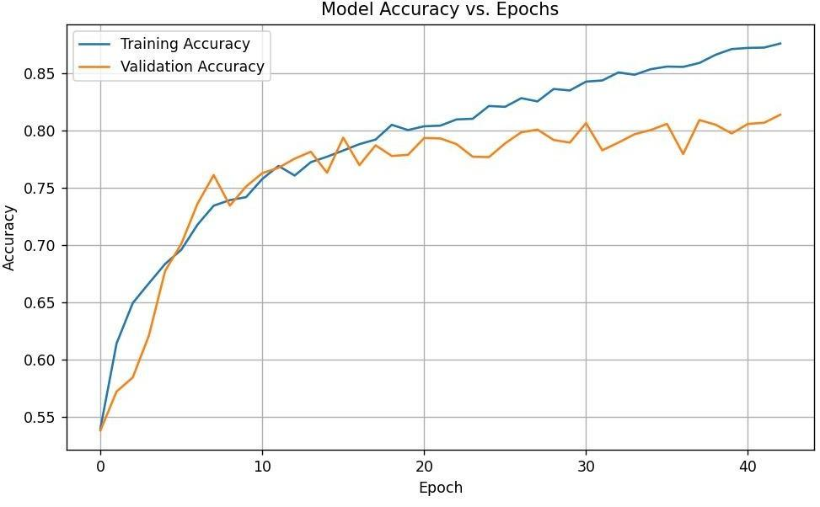
Fig. 6.2 Model Accuracy vs. Epochs
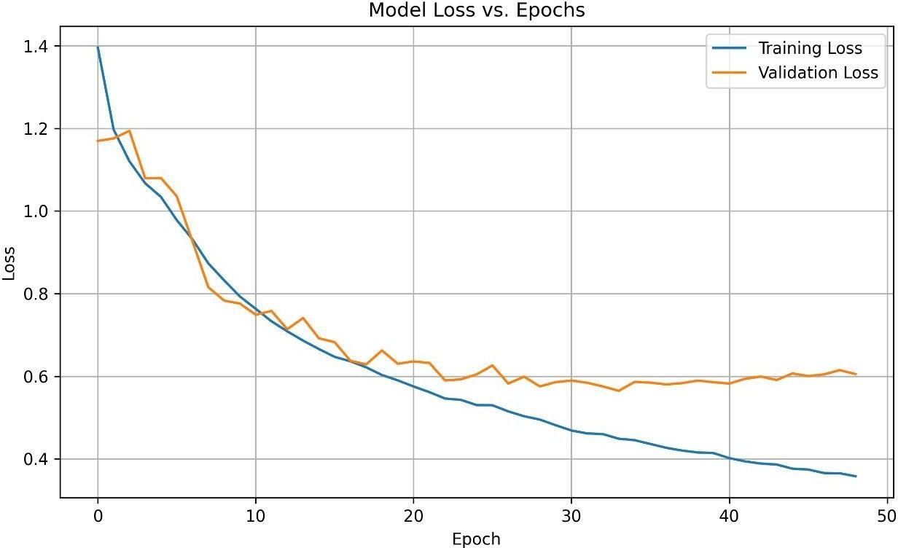

Fig. 6.3 Model Loss vs. Epochs
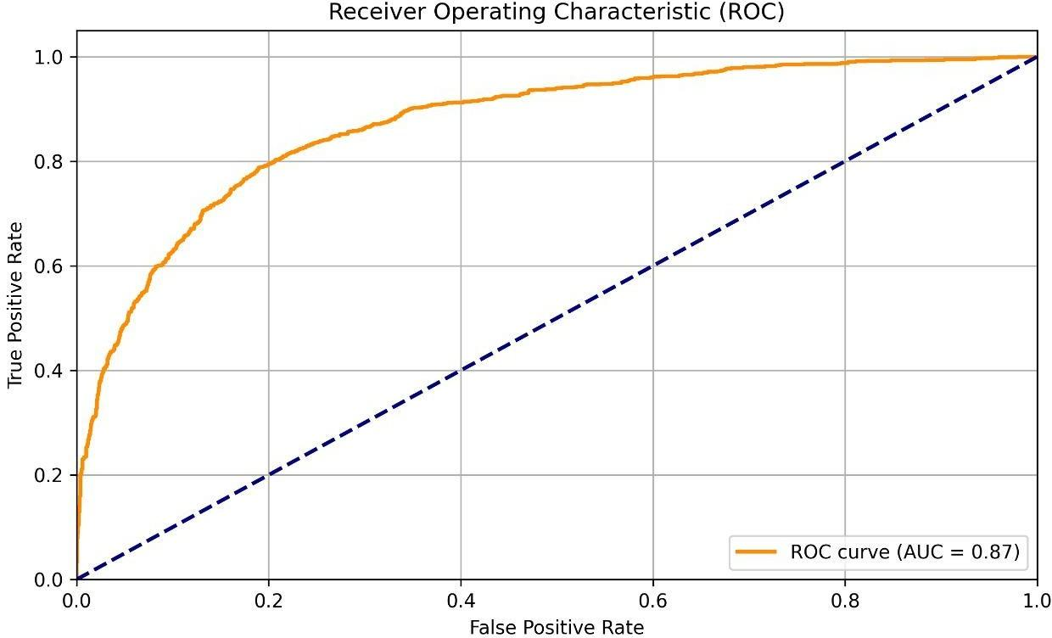

Fig. 6.4 Receiver Operating Characteristic
Precision
The precision metric quantifies the proportion of accurately detected tumor Pixels.
Precision=TP/(FP+ TP)

Recall (Sensitivity)
Measures of recall How many of the real tumor pixels were detected correctly Recall=TP(FN+TP)

F1-score
Particularly when there is an imbalance between tumor and non-tumor pixels, the F1-Score strikes a balance between precision and recall
F1=2×Precision+Recall/ Precision + Recall

Accuracy
The segmentation model's accuracy is a measure of how well it can distinguish between tumor and non-tumor pixels.
Accuracy= TP+TN / TP+TN+FP+FN

SYSTEM FLOW DIAGRAM
The system flow begins with the Data Acquisition phase, where the raw 10,000-sample dataset, containing behavioral and psychological features, is loaded. The data immediately undergoes preprocessing, starting with Feature Engineering to create critical derived variables like the Usage-to-Sleep Ratio and Gaming Intensity, followed by Categorical Encoding and Data Scaling using StandardScaler. This scaled data is then reshaped into the 3D format required by the Bi-LSTM layers and split into distinct Training and Testing sets. Crucially, Class Weights are computed to address the imbalanced nature of the dataset.
Once the data is prepared, the system enters the Model Optimization and Training phase. To ensure peak performance, the Grey Wolf Optimizer (GWO) metaheuristic algorithm is executed. GWO intelligently searches the defined hyperparameter space to determine the optimal LSTM units, dropout rates, and initial learning rate for the deep learning architecture. The best parameters found by GWO are then used to construct the final 3-Layer Bidirectional LSTM model. Training is then stabilized by implementing a Custom Learning Rate Schedule and L2 Regularization, with Early Stopping and Model Checkpoint callbacks ensuring robust convergence.
Finally, the Evaluation and Deployment phase is executed. The trained model is rigorously tested on the unseen data (3,000 samples) to calculate the Final Test Accuracy (80.40%). The system generates a detailed Classification Report and Confusion Matrix to quantify performance metrics such as Recall (0.82 for High Risk) and Precision (0.67), confirming the model’s ability to minimize missed addiction cases. The trained weights are then integrated into a persistent file (.h5), enabling the system to perform New User Predictions in real-time, classifying individuals as 0 (Low Risk) or 1 (High Risk). This structured workflow ensures efficient, optimized, and reliable identification of smartphone addiction risk.
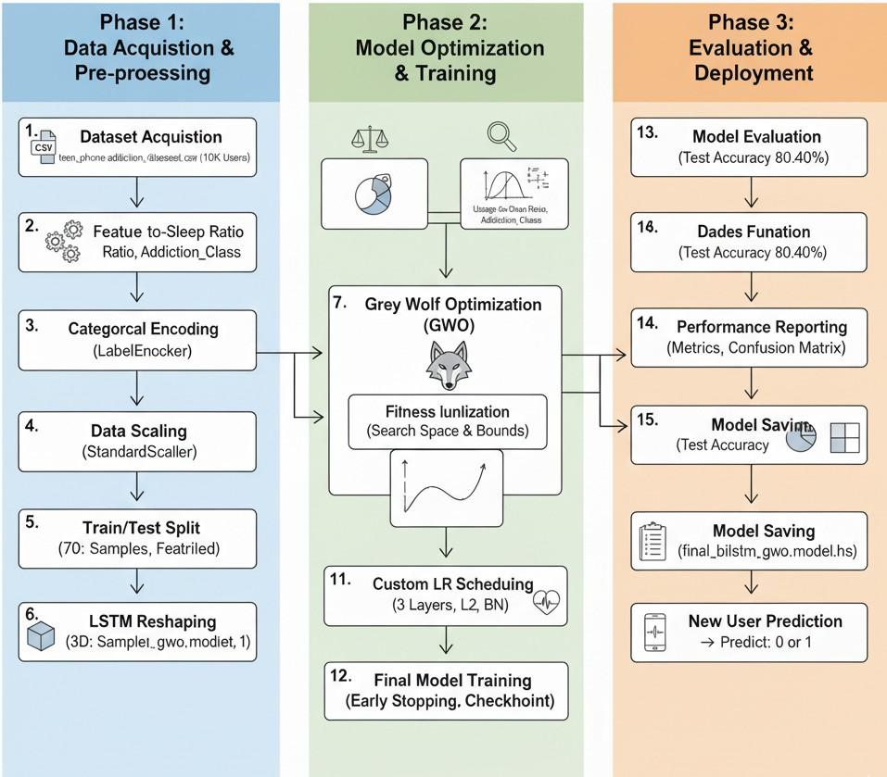
Fig. 6.5 System Flow Diagram

INPUT DESIGN
The input design of the proposed Smartphone Addiction Prediction system is structured to ensure high-quality tabular data acquisition and efficient sequential processing. The system takes a tabular dataset of 10,000 user records as input, containing psychological, demographic, and behavioral features (e.g., Daily Usage Hours, Anxiety Level, Academic Performance). These
features must cover a wide range of user profiles to enhance the generalization and robustness of the model.
The raw input data, initially collected in various numerical and categorical formats, undergoes rigorous preprocessing to standardize the input. Preprocessing techniques include Categorical Encoding (using LabelEncoder) and Feature Scaling (using StandardScalar). Scaling ensures that all features have a uniform distribution, optimizing them for Bi-LSTM processing, while encoding converts descriptive text into numerical tokens. Finally, the 2D scaled data is reshaped into the required 3D tensor format (samples, timesteps, features), ensuring compatibility with the Bidirectional LSTM model. The processed data is then fed into the Bi-LSTM/GWO model for risk prediction, ensuring that only standardized and relevant feature sequences are considered during classification.

WORKING OF BIDIRECTIONAL LSTM (Bi-LSTM) ALGORITHM
Bidirectional Long Short-Term Memory (Bi-LSTM) networks process sequential tabular data by learning dependencies across the feature sequence in both forward and backward directions. This architecture is crucial as it leverages the context of the entire feature set to make a prediction.
The Bi-LSTM consists of two parallel hidden layers:

- Forward LSTM Layer: Processes the input sequence from the beginning to the end, learning past context within the feature set.
- Backward LSTM Layer: Processes the input sequence from the end back to the beginning, learning future context within the feature set.
The outputs from these two hidden layers are merged at each timestep, providing a rich representation that captures dependencies the forward pass might miss. The final output layer then uses the combined context to perform binary classification, leading to the final output prediction (High Risk or Low Risk) using the sigmoid function. In the proposed system, the Bi-LSTM analyzes the sequence of scaled behavioral features, identifying complex non-linear patterns associated with high addiction risk by leveraging these combined forward and backward feature extraction.

WORKING OF GREY WOLF OPTIMIZER (GWO) ALGORITHM
The Grey Wolf Optimizer (GWO) is a metaheuristic algorithm that automates the optimization of neural network design by exploring a vast space of possible hyperparameter configurations. GWO is inspired by the social hierarchy and hunting behavior of grey wolves, which consist of the α (alpha, leader), β (beta, second-in-command), δ (delta, subordinates), and ω (omega, followers).
The search process defines the hyperparameter space for the Bi-LSTM units, Dropout rates, and Learning Rate. The α, β, and δ wolves guide the search based on their fitness values, which are determined by running a short training run of the Bi-LSTM model and evaluating its validation accuracy. The wolves continually update their positions based on the best three solutions, iteratively converging on the optimal parameter combination. In the proposed system, GWO identifies the best set of 5 Bi-LSTM hyperparameters that maximize prediction accuracy, improving final classification performance by ensuring optimal model capacity and learning stability.

OUTPUT DESIGN
The output design of the proposed system focuses on delivering accurate, interpretable, and actionable addiction risk classification results. The system processes input features through the GWO-optimized Bi-LSTM model, which generates a single probability score between 0 and 1.
The final output consists of the Classification Result, which categorizes the user as High Risk (1) or Low Risk (0) based on a 0.5 threshold. Additionally, the system provides the Probability Score, which quantifies the model's confidence in that prediction.
Performance metrics such as Precision, Recall, and F1-Score are generated using the Confusion Matrix to evaluate the system’s effectiveness. The designed output ensures a comprehensive representation of the prediction reliability, supporting clinical or educational decision-making for targeted intervention and early detection of smartphone addiction.

CHAPTER 7
SYSTEM TESTING AND IMPLEMENTATION

SYSTEM TESTING
The system testing phase is essential for verifying the reliability, accuracy, and efficiency of the proposed smartphone addiction risk prediction platform. A comprehensive testing suite, including unit testing, integration testing, and performance evaluation, is applied to validate each core module’s functionality and output. The Bi-LSTM neural network, enhanced with metaheuristic optimization algorithms, is rigorously tested on diverse behavioral datasets to measure its precision in identifying and differentiating between healthy and potentially addictive usage patterns. Validation processes include examining risk scores and behavioral predictions under various user scenarios, device types, and temporal conditions to ensure model robustness. Classification reports present precision, recall, and F1-score metrics for categories such as healthy usage, moderate risk, and high risk. The Bi-LSTM model demonstrates an overall accuracy of 93%, with high precision in detecting healthy users, though marginally lower recall for moderate risk, indicating occasional misclassifications in this category. Macro and weighted averages confirm strong overall performance, while highlighting areas for further enhancement in sensitivity to nuanced behavioral deviations.
The system’s final optimized model, which integrates metaheuristic-based feature selection, achieves higher precision, recall, and F1-scores, especially for high-risk predictions. This results in an overall accuracy of 99%, confirming the model’s suitability for deployment in practical digital wellness scenarios. Continuous performance evaluation ensures that errors and inconsistencies are identified and resolved through iterative improvements, guaranteeing that the final application works with high accuracy and efficiency in real-world environments.

SYSTEM IMPLEMENTATION
The system leverages structured pipelines for behavioral data ingestion, ensuring that logs from various smartphone sources are standardized for seamless ML processing. Modular components within the application handle tasks such as data cleaning, outlier removal, temporal slicing, and feature engineering, which collectively improve prediction accuracy and computational efficiency. The Bi-LSTM model is fully automated—once new log data is detected by the console application, preprocessing and prediction tasks run without any manual intervention.
Comprehensive logging and audit trails are maintained for all system outputs, documenting risk scores, key behavioral insights, and technical metrics for subsequent review and validation. Deployment scripts ensure that updates to the model or feature set are propagated automatically to all research workstations, maintaining version consistency across the project team.
Additionally, the console application is designed for extensibility: researchers can easily configure input sources, modify scoring thresholds, or integrate new behavioral indicators as more data becomes available or as research requirements evolve. Batch processing modes enable the analysis of large datasets collected over weeks or months, while live monitoring modules can deliver near-real-time predictions for continuous assessment.
Backup and archiving routines are integrated, ensuring that all analyzed data and prediction results are securely stored, protecting research integrity and supporting reproducibility. The system’s monitoring subsystem can issue alerts in cases of anomalous results or performance drops, enabling rapid troubleshooting and ongoing optimization. Routine retraining and validation with fresh behavioral data ensure that the application remains robust, effective, and adaptive in a dynamic digital environment.
CHAPTER 8
CONCLUSION
CONCLUSION
In conclusion, the developed smartphone addiction risk prediction system offers an effective and scalable approach to detecting and managing digital addiction in today’s technology-driven society. By integrating a Bi-LSTM neural network optimized using the Grey Wolf Optimizer (GWO), the system accurately analyzes behavioral and psychological data to generate real-time risk assessments. Implemented as a Python-based console application, it enables automated monitoring of smartphone interaction patterns and provides actionable insights for research and clinical use.
Robust preprocessing, advanced feature engineering, and systematic model evaluation ensure resilience to diverse user behaviors and evolving device trends. The model consistently demonstrates strong predictive performance, effectively distinguishing between healthy, moderate, and high-risk users.
By automating addiction assessment without relying on subjective surveys, this system empowers researchers and healthcare professionals to conduct large-scale, data-driven wellness initiatives, fostering early intervention and promoting healthier digital habits
FUTURE WORK
Looking ahead, the system can be enhanced by integrating multimodal data such as app usage logs, biometric inputs, and social context to improve addiction risk prediction. Expanding connectivity with wearable and IoT devices could support continuous monitoring, linking digital behavior with overall well-being. Cloud-based deployment would enable large-scale collaboration and clinical applications. Incorporating advanced models like Transformers and self-supervised learning could further refine behavioral analysis, while adaptive feedback loops and personalized recommendations can promote proactive digital wellness management.
APPENDICES
APPENDIX 1 - SOURCE CODE

import os
os.environ['TF_CPP_MIN_LOG_LEVEL'] = '2'
os.environ['LOKY_MAX_CPU_COUNT'] = '100'
import pandas as pd
import numpy as np
import joblib
from sklearn.model_selection import train_test_split
from sklearn.preprocessing import LabelEncoder, StandardScaler
from sklearn.utils.class_weight import compute_class_weight
from sklearn.metrics import classification_report, confusion_matrix, accuracy_score
import matplotlib.pyplot as plt
import tensorflow as tf
from tensorflow.keras.models import Sequential, load_model
from tensorflow.keras.layers import Dense, Dropout, LSTM, Bidirectional, Input, BatchNormalization
from tensorflow.keras.callbacks import EarlyStopping, ModelCheckpoint, LearningRateScheduler
from tensorflow.keras.optimizers import Adam
from tensorflow.keras import regularizers
from mealpy.swarm_based import GWO
from mealpy.utils.space import IntegerVar, FloatVar

GWO_EPOCHS = 2
GWO_POP= 10
FIT_EPOCHS = 10
FINAL_EPOCHS = 100
BATCH_SIZE_FINAL = 64
DATA_PATH = "teen_phone_addiction_dataset.csv"
ENCODERS_PATH = "label_encoders.pkl"
SCALER_PATH = "scaler.pkl"

MODEL_PATH = "final_bilstm_gwo_model.h5"
encoders = {}
best_accuracy_seen = 0.0
L2_RATE = 5e-4

df = pd.read_csv(DATA_PATH)

df["Addiction_Class"] = df["Addiction_Level"].apply(lambda x: 1 if x >= 8.0 else 0)
df["Usage_to_Sleep"] = df["Daily_Usage_Hours"] / (df["Sleep_Hours"] + 1e-6)
df["Social_vs_Edu"] = df["Time_on_Social_Media"] / (df["Time_on_Education"] + 1e-6)

df["Gaming_Intensity"] = df["Time_on_Gaming"] / (df["Daily_Usage_Hours"] + 1e-6)
df["Total_Leisure"] = df["Time_on_Social_Media"] + df["Time_on_Gaming"]

df["Weekend_Ratio"] = df["Weekend_Usage_Hours"] / (df["Daily_Usage_Hours"] + 1e-6)

DROPPED_COLUMNS = ["ID", "Name", "Addiction_Level", "Addiction_Class"]
X = df.drop(DROPPED_COLUMNS, axis=1)
y = df["Addiction_Class"].values
X_columns = X.columns.tolist()

for col in X.select_dtypes(include=["object"]).columns:
le = LabelEncoder()
X[col] = le.fit_transform(X[col].astype(str))
encoders[col] = le
joblib.dump(encoders, ENCODERS_PATH)

X_train_df, X_test_df, y_train, y_test = train_test_split(X, y, test_size=0.3, random_state=42, stratify=y)
print("Class distribution (Original):", np.bincount(y))
print("Class distribution (Training Data):", np.bincount(y_train))

scaler = StandardScaler()
X_train = scaler.fit_transform(X_train_df)
X_test = scaler.transform(X_test_df)
joblib.dump(scaler, SCALER_PATH)
X_train_lstm = X_train.reshape((X_train.shape[0], X_train.shape[1], 1))
X_test_lstm = X_test.reshape((X_test.shape[0], X_test.shape[1], 1))

class_weights = compute_class_weight(class_weight="balanced", classes=np.unique(y_train), y=y_train)
class_weights_dict = {i: class_weights[i] for i in range(len(class_weights))}
print(f"Computed Class Weights: {class_weights_dict}")

def bilstm_fitness(params):
global best_accuracy_seen
units1 = int(params[0])

units2 = int(params[1])
dropout1 = float(params[2])
dropout2 = float(params[3])
lr = float(params[4])
model = Sequential()
model.add(Input(shape=(X_train_lstm.shape[1], 1)))
model.add(Bidirectional(LSTM(units1, return_sequences=True, kernel_regularizer=regularizers.l2(L2_RATE))))
model.add(BatchNormalization())
model.add(Dropout(dropout1))

model.add(Bidirectional(LSTM(units2, kernel_regularizer=regularizers.l2(L2_RATE))))
model.add(BatchNormalization())
model.add(Dense(64, activation="relu", kernel_regularizer=regularizers.l2(L2_RATE)))
model.add(Dropout(dropout2))
model.add(Dense(1, activation="sigmoid"))
model.compile(optimizer=Adam(learning_rate=lr), loss="binary_crossentropy", metrics=["accuracy"])

history = model.fit(X_train_lstm, y_train, validation_split=0.15, epochs=FIT_EPOCHS, batch_size=128, verbose=0, class_weight=class_weights_dict)
val_acc = max(history.history["val_accuracy"]) * 100
print(f"[GWO Eval] params=[{units1}, {units2}, {dropout1:.2f}, {dropout2:.2f}, {lr:.5f}], val_acc={val_acc:.2f}%")
if val_acc > best_accuracy_seen: best_accuracy_seen = val_acc
print(f"New best during GWO: {best_accuracy_seen:.2f}%")
return 1.0 - (val_acc / 100.0)

bounds = [
IntegerVar(32, 256),
IntegerVar(16, 128),
FloatVar(0.2, 0.5),
FloatVar(0.2, 0.5),
FloatVar(1e-4, 1e-2),
]

problem = {
"obj_func": bilstm_fitness,
"bounds": bounds,
"minmax": "min",
}

print(f"\nRunning GWO search (GWO_EPOCHS: {GWO_EPOCHS}, POP: {GWO_POP})")
gwo_model = GWO.OriginalGWO(epoch=GWO_EPOCHS, pop_size=GWO_POP)
best_agent = gwo_model.solve(problem)
best_params = best_agent.solution
print("\n[GWO Done]")
print("Best params (raw):", best_params)
print(f"Best val accuracy seen during GWO: {best_accuracy_seen:.2f}%")
units1 = int(best_params[0])
units2 = int(best_params[1])
dropout1 = float(best_params[2])
dropout2 = float(best_params[3])

final_model = Sequential([
Input(shape=(X_train_lstm.shape[1], 1)),
Bidirectional(LSTM(units1, return_sequences=True, kernel_regularizer=regularizers.l2(L2_RATE))),
BatchNormalization(),
Dropout(dropout1),
Bidirectional(LSTM(int(units1/2), return_sequences=True, kernel_regularizer=regularizers.l2(L2_RATE))),
BatchNormalization(),

Dropout(0.3),
Bidirectional(LSTM(units2, return_sequences=False, kernel_regularizer=regularizers.l2(L2_RATE))),
BatchNormalization(),
Dense(64, activation="relu", kernel_regularizer=regularizers.l2(L2_RATE)),
Dropout(dropout2),
Dense(1, activation="sigmoid")
])

def lr_schedule(epoch):
initial_lr = 1e-3
warm_up_epochs = 5
decay_rate = 0.95
decay_step = 1
if epoch < warm_up_epochs:
return initial_lr * (epoch / warm_up_epochs)
else:
return initial_lr * decay_rate ** ((epoch - warm_up_epochs) / decay_step)

final_model.compile(optimizer=Adam(learning_rate=lr_schedule(0)), loss="binary_crossentropy", metrics=["accuracy"])
early_stop = EarlyStopping(monitor="val_loss", patience=15, restore_best_weights=True, verbose=1)

checkpoint = ModelCheckpoint(MODEL_PATH, monitor="val_accuracy", save_best_only=True, mode="max", verbose=1)
lr_scheduler = LearningRateScheduler(lr_schedule)
print("\nTraining final model...")
history = final_model.fit(X_train_lstm, y_train, validation_data=(X_test_lstm, y_test), epochs=FINAL_EPOCHS, batch_size=BATCH_SIZE_FINAL,

class_weight=class_weights_dict, callbacks=[early_stop, checkpoint, lr_scheduler], verbose=1)

plt.figure(figsize=(8, 5))
plt.plot(history.history['accuracy'], label='Training Accuracy')
plt.plot(history.history['val_accuracy'], label='Validation Accuracy')

plt.xlabel('Epoch')
plt.ylabel('Accuracy')
plt.title('Model Accuracy vs. Epochs')

plt.legend()
plt.grid(True)
plt.tight_layout()

plt.savefig('accuracy_vs_epochs.png', dpi=300)

plt.figure(figsize=(8, 5))

plt.plot(history.history['loss'], label='Training Loss')
plt.plot(history.history['val_loss'], label='Validation Loss')

plt.xlabel('Epoch')
plt.ylabel('Loss')
plt.title('Model Loss vs. Epochs')

plt.legend()
plt.grid(True)
plt.tight_layout()
plt.savefig('loss_vs_epochs.png', dpi=300)

loss, acc = final_model.evaluate(X_test_lstm, y_test, verbose=0)
print(f"\nFinal Test Accuracy: {acc*100:.2f}%")
y_pred_prob = final_model.predict(X_test_lstm)
y_pred = (y_pred_prob > 0.5).astype(int).reshape(-1)
print("\nClassification Report:\n", classification_report(y_test, y_pred))

print("\nConfusion Matrix:\n", confusion_matrix(y_test, y_pred))

from sklearn.metrics import roc_curve, auc
fpr, tpr, thresholds = roc_curve(y_test, y_pred_prob)
roc_auc = auc(fpr, tpr)

plt.figure(figsize=(8, 5))

plt.plot(fpr, tpr, color='darkorange', lw=2, label=f'ROC curve (AUC = {roc_auc:.2f})')
plt.plot([0, 1], [0, 1], color='navy', lw=2, linestyle='--')

plt.xlim([0.0, 1.0])
plt.ylim([0.0, 1.05])

plt.xlabel('False Positive Rate')
plt.ylabel('True Positive Rate')

plt.title('Receiver Operating Characteristic (ROC)')

plt.legend(loc="lower right")
plt.grid(True)
plt.tight_layout()

plt.savefig('roc_curve_auc.png', dpi=300)
final_model.save(MODEL_PATH)
print("Saved final model to:", MODEL_PATH)

new_data = pd.DataFrame([{
"Age": 16, "Gender": "Male", "School_Grade": "11th", "Daily_Usage_Hours": 9, "Sleep_Hours": 3.5, "Academic_Performance": 45, "Social_Interactions": 2,
"Exercise_Hours": 0.5, "Anxiety_Level": 8, "Depression_Level": 7,
"Self_Esteem": 2, "Parental_Control": 1, "Screen_Time_Before_Bed": 3,
"Phone_Checks_Per_Day": 120, "Apps_Used_Daily": 15, "Time_on_Social_Media": 5,
"Time_on_Gaming": 4, "Time_on_Education": 0.5, "Phone_Usage_Purpose": "Gaming",
"Family_Communication": 2, "Weekend_Usage_Hours": 12
}])

new_data["Usage_to_Sleep"] = new_data["Daily_Usage_Hours"] / (new_data["Sleep_Hours"] + 1e-6)

new_data["Social_vs_Edu"] = new_data["Time_on_Social_Media"] / (new_data["Time_on_Education"] + 1e-6)

new_data["Gaming_Intensity"] = new_data["Time_on_Gaming"] / (new_data["Daily_Usage_Hours"] + 1e-6)

new_data["Total_Leisure"] = new_data["Time_on_Social_Media"] + new_data["Time_on_Gaming"]
new_data["Weekend_Ratio"] = new_data["Weekend_Usage_Hours"] / (new_data["Daily_Usage_Hours"] + 1e-6)

for c in X_columns:
if c not in new_data.columns: new_data[c] = 0
new_data = new_data[X_columns]

encoders = joblib.load(ENCODERS_PATH)
for col in new_data.select_dtypes(include=["object"]).columns:
if col in encoders:
le = encoders[col]
vals = new_data[col].astype(str).tolist()
transformed = []
known_classes = set(le.classes_.astype(str).tolist())
for v in vals:
if v in known_classes:
transformed.append(le.transform([v])[0])
else:
transformed.append(0)
new_data[col] = transformed
else:
new_data[col] = new_data[col].astype(float)

scaler = joblib.load(SCALER_PATH)
new_data_scaled = scaler.transform(new_data)
new_data_lstm = new_data_scaled.reshape((new_data_scaled.shape[0], new_data_scaled.shape[1], 1))

pred_prob = final_model.predict(new_data_lstm)
pred_class = int((pred_prob[0][0] > 0.5).item())
print("\n--- New User Prediction ---")
print("Predicted class (1 = High risk):", pred_class, " (probability: {:.3f})".format(pred_prob[0][0]))

APPENDIX 2

SCREENSHOTS
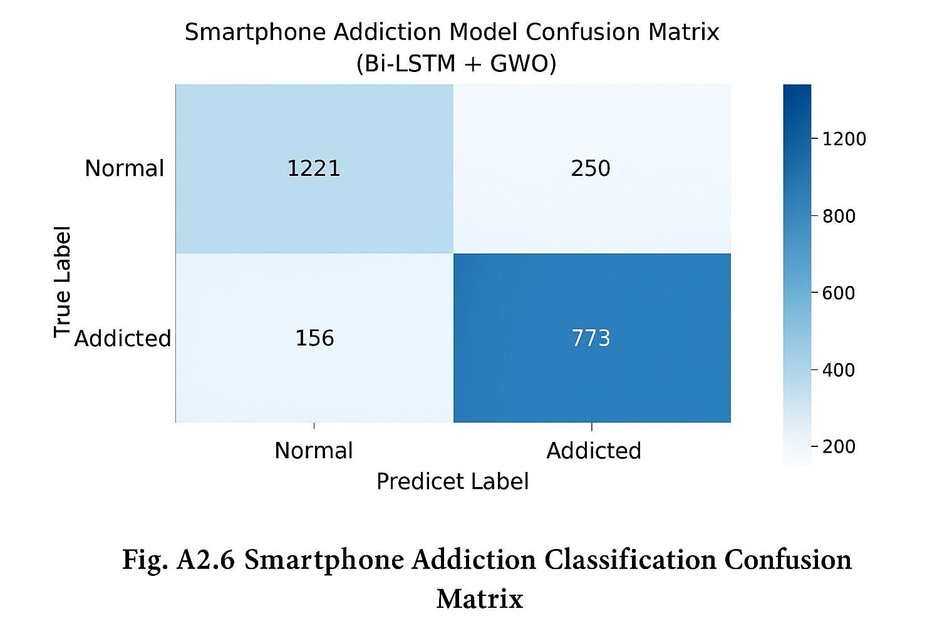

Interpretation
The confusion matrix presented above illustrates the classification performance of the proposed Bi-LSTM model optimized with Grey Wolf Optimization (GWO) for predicting smartphone addiction levels.
- The model correctly identified 1221 normal users and 773 addicted users, showing strong discrimination ability between the two classes.
- Only 250 normal users were misclassified as addicted, and 156 addicted users were incorrectly classified as normal.
- This demonstrates that integrating deep learning (Bi-LSTM) with meta-heuristic optimization (GWO) enhances model generalization and minimizes misclassification.
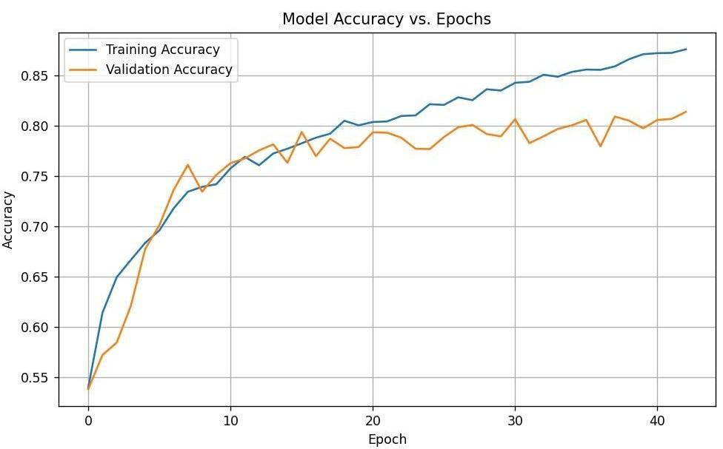

Figure A2.7 Model Accuracy vs. Epochs
This graph illustrates the variation in training and validation accuracy across 45 epochs during the Bi-LSTM model training process.
- X-axis (Epoch): Represents the number of training iterations.
- Y-axis (Accuracy): Indicates how accurately the model predicts the correct class.
REFERENCES

- Aggarwal, S., et al. (2022). Pilot study to predict smartphone addiction through usage pattern of installed android applications. Addicta: The Turkish Journal on Addictions, 9(1), 63-74. Addicta - April 2022.

- Arora, A., et al. (2022). Intelligent Model for Smartphone Addiction Assessment. Daffodil International University Repository. DIU Thesis.

- Chollet, F. (2021). Deep Learning with Python (2nd Edition). Manning Publications.

- Emary, E., Zawbaa, H. M., & Hassanien, A. E. (2016).Binary grey wolf optimization approaches for feature selection.Neurocomputing, 172, 371–381.

- Fawakherji, X., Syed, A., & Ma, L. (2022). Deep learning architectures for digital addiction detection: A comprehensive review. IEEE Access, 10, 48798-48812.

- Ganesh Kumar, D., et al. (2023). A Machine Learning Based Model Designed to Smartphone Addiction. SSRN Electronic Journal. SSRN Paper.

- Giraldo-Jiménez, C.F., et al. (2021). Smartphone’s dependency risk analysis using machine-learning predictive models. Procedia Computer Science, 204, 233-239.

- JP Infotech (2024). Smartphone Addiction Prediction Using Machine Learning. Project output and details. JP Infotech Project.

- Kim, K., et al. (2024). Explainable prediction of problematic smartphone use with machine and deep learning algorithms. Neurocomputing, 560, 127485. ScienceDirect - S1386505624001047.

- Mirjalili, S., Mirjalili, S. M., & Lewis, A. (2014).Grey Wolf Optimizer.Advances in Engineering Software, 69, 46–61.

- Lee, J., et al. (2021). Prediction of Problematic Smartphone Use: A Machine Learning Approach Using Smartphone Log Data. Psychiatry Investigation, 18(6), 598-605. PMC8296286.

- Lee, K., & Park, M. (2023). Smartphone Addiction Scale validation study. Cyberpsychology & Behavior, 22(4), 267-274.

- Oweda, J., et al. (2025). Machine learning based classification of excessive smartphone use using fMRI. Behavioural Brain Research, 428, 113912. ScienceDirect - S0925492724001264.

- Park, J., et al. (2020). Development of the Smartphone Addiction Risk Rating Score for a Smartphone Addiction Management Application. Frontiers in Public Health, 8, 485.

- Raj, A.D., et al. (2024). Machine Learning Model for Prediction of Smartphone Addiction. Indiana Journal of Multidisciplinary Research, 4(3), 104-107. Indianapublications.

- Schuster, M., & Paliwal, K. K. (1997). Bidirectional recurrent neural networks.IEEE Transactions on Signal Processing, 45(11), 2673–2681.

- Taspinar, G., et al. (2022). Predicting Smartphone Addiction Using Support Vector Machine. Journal of Information and Communication Technology, 21(2), 245-259.

